Code :
library IEEE;
use IEEE.STD_LOGIC_1164.ALL;
use IEEE.STD_LOGIC_ARITH.ALL;
use IEEE.STD_LOGIC_UNSIGNED.ALL;
Port ( a : in STD_LOGIC_VECTOR (3 downto 0);
b : in STD_LOGIC_VECTOR (3 downto 0);
sel : in STD_LOGIC_VECTOR (2 downto 0);
y : out STD_LOGIC_VECTOR (3 downto 0));
end ALUBATCH;

architecture Behavioral of ALUBATCH is
begin
process(a, b, sel)
begin
case sel is
when "000" => y <= a + b;
when "001" => y <= a - b;
when "010" => y <= a AND b;
when "011" => y <= a OR b;
when "100" => y <= a XOR b;
when "101" => y <= a XNOR b;
when "111" => y <= a;
when others => y <= "0000";
end case;
end process;
end Behavioral;
Pin Assignment :

I/O Name | I/O Direction | Loc | Bank
a[0] | Input | P206 | BANK0
a[1] | Input | P205 | BANK0
a[2] | Input | P203 | BANK0
a[3] | Input | P200 | BANK0
b[0] | Input | P192 | BANK0
b[1] | Input | P193 | BANK0
b[2] | Input | P189 | BANK0
b[3] | Input | P190 | BANK0
sel<0> | Input | P179 | BANK0
sel<1> | Input | P180 | BANK0
sel<2> | Input | P165 | BANK0
sel<3> | Input | P167 | BANK0
y<0> | Output | P164 | BANK0
y<1> | Output | P163 | BANK0
y<2> | Output | P162 | BANK0

RTL Diagram :

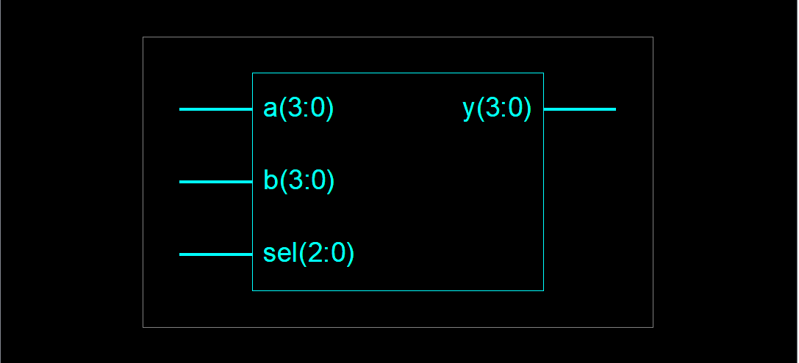

Output :

